Officers/Board Members
Robert Davalt - President
Email: rdavalt@gmail.com
Ron Huisenga– Vice President
Email: ron-huisenga@comcast.net
Mark Bullard – Treasurer
Email: mbullard@veneziainc.com
Heather Wright – Secretary
Email: HeatherWright@comcast.net

Our Story: In 2018 a small group of dedicated/caring individuals banded together to create The Lost Highway Cruisers,Inc. A blend of car, truck and motorcycle enthusiasts having fun, enjoying their rides while helping the Community. The Lost Highway Cruisers main focus is on local Veterans. Throughout the year we will be volunteering on some local charity projects. We are a 501c3 non-profit organization.
We enjoy visiting other shows, becoming friends with other clubs, visiting automotive related exhibits and destinations as well as participate in some great charity events. We yearn to hit the road, go places, try new things. Come take a journey with us…..

NEW MEMBERSHIP APPLICATION

Today's Date:______________________________
NAME:____________________________________
Birth date: _________________________________
Address:___________________________________
City/State/Zip:______________________________ Spouse’s name:_____________________________ Phone Number:_____________________________
Email Address: ______________________________
Own a classic or Muscle cars? __________________
If you do: year/make and Models: ______________ ____________________________________________
__________________________________________
What would you like to participate in? Club meetings or Car Shows or Car cruise or volunteer/benefit: ____________________________________________ ____________________________________________ Yearly Dues are just $20.00

If mailing your application, please mail to:
Lost Highway Cruisers, Inc.
P O BOX 901
Royersford, Pa. 19468
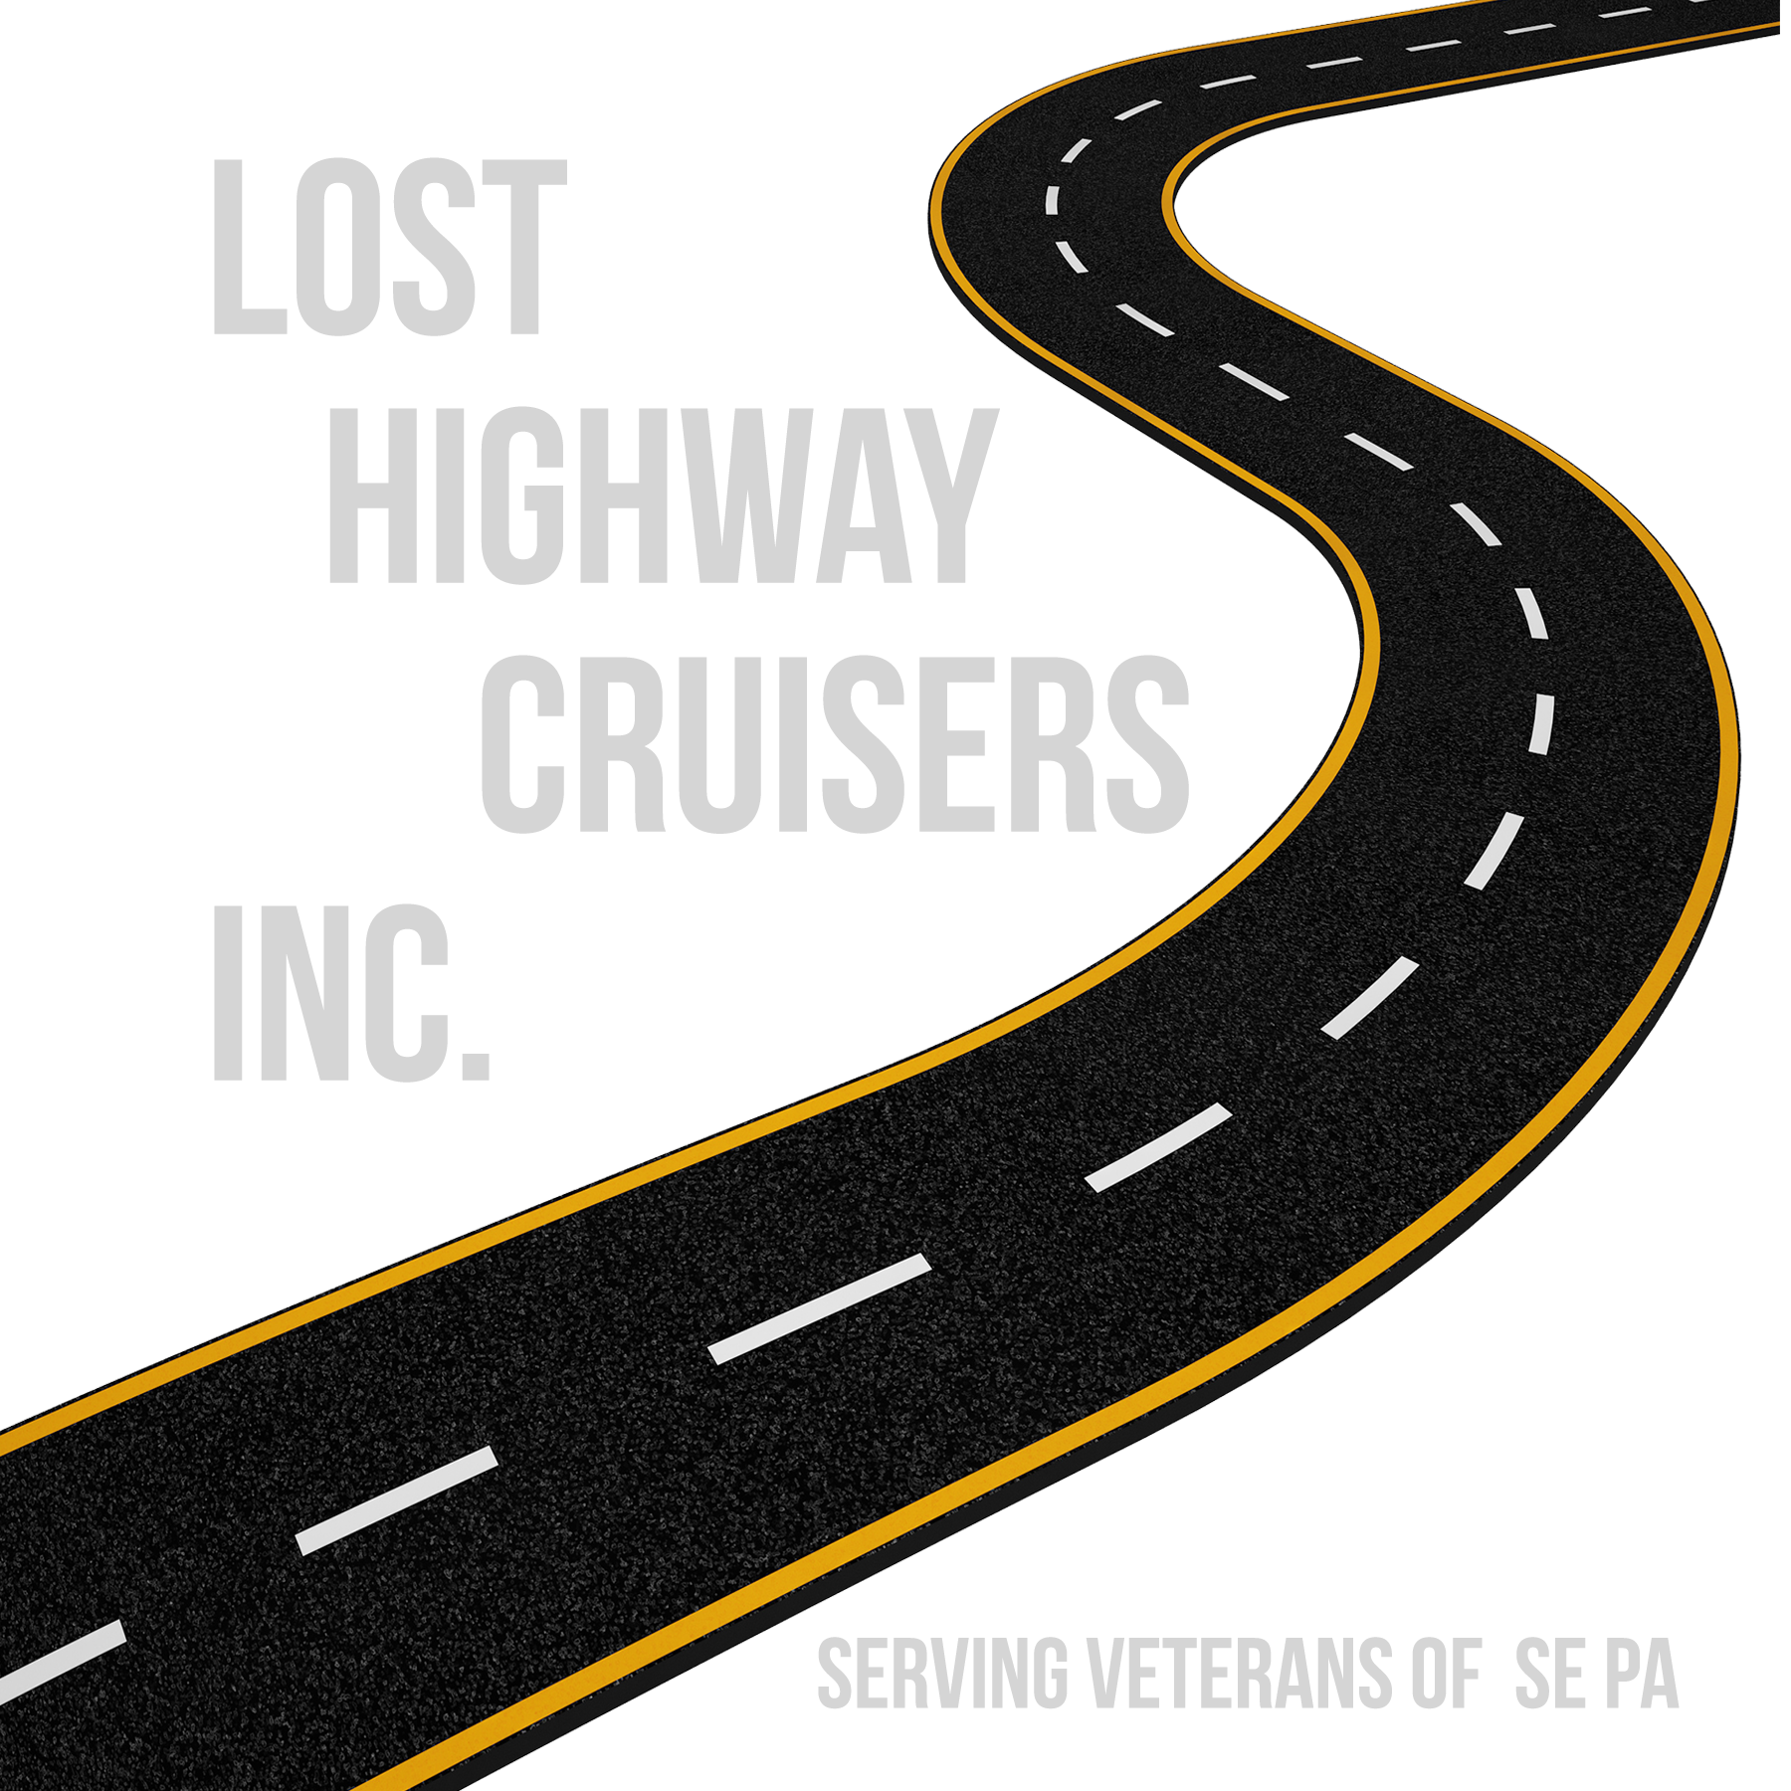
Come take a journey with us.......

www.LostHighwayCruisersInc.com

